**LASER BEAM MACHINING (LBM) (CUTTING/DRILLING/WELDING)**

## (LASER İLE İŞLEME (KESME / DELME / KAYNAK))

**LASER (Light Amplification Using Stimulated Emission of Radiation)**

Sun's radiation:    7 kW/cm2 (on sun's surface)

In laser for short pulses:    10 kW/cm2(on beam cross section)

**Principles**

-If a laser beam is focused on (1/100) of mm2, E=105 kW/cm2, this heat vaporize any known materials.

-The laser rod is exited by xenon filled flash lamp, which surrounds it.

E(usable) = 106 - 107 kW/cm2

■ = Eusable / Esupply = 0.5 - 50 %

**Material Removal Mechanism**

Melting and evaporation of workpiece material under extensive heat.

**Utilization of heat energy**

|  |  |
| --- | --- |
|  | 1. A part is reflected and lost. |
|  | 1. Most of energy is used for melting. |
|  | 1. Small part is for evaporation. |
|  | 1. Very small is conducted into unmelted base material. |
|  | 1. Very small is absorbed on the way and by the evaporated and emitted droplets. |

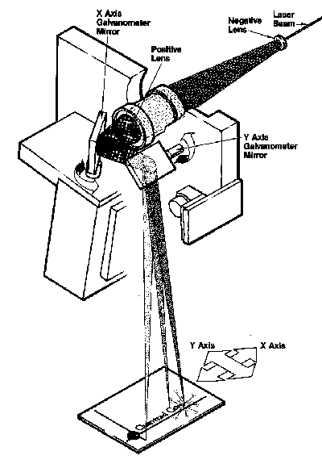

 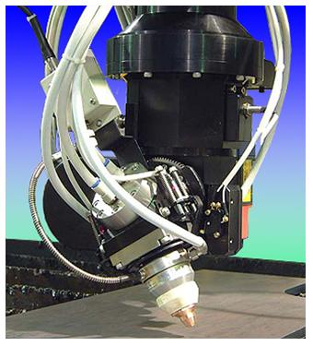

5-DOF Laser Drilling Machine

(a)

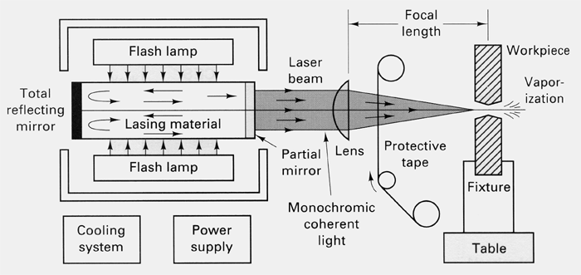

(b)

Figure 13.1 LBM Mechanism

**Laser Types and Materials**

|  |  |  |
| --- | --- | --- |
| Continuous waves (CW) | C:\Documents and Settings\SDAG\Desktop\CCOGUN\Web Final\images\paranthesis2.gif | Heavy and continuous machining |
| Pulsed waves | C:\Documents and Settings\SDAG\Desktop\CCOGUN\Web Final\images\paranthesis2.gif | drilling of small areas |
| for thin material (sheets) |

Laser materials and performances

|  |  |  |  |  |
| --- | --- | --- | --- | --- |
| Laser Material | Wavelength (m) | Mean Power (W) |  (%) | Relative Cost |
| CO2 (gas) | 10.2 | 100 - 25.000 (400 - 1.500 common) | < 10 | 400 |
| Nd YAG (Continuous) * | 1.06 | Av. 400 (peak 20.000) | < 1 | 10 - 44 |
| Nd YAG (Pulsed) * |
| Argon (gas) | 351 - 529 | - | < 0.1 | 3 - 9 |
| CO (gas) | - | 2000 | 60 |  |

* Solid state of neodymium, yttrium-aluminum-garnet

**Metallurgical Effects**

-Heat affected zone is very narrow (min. 0.025, max. 1 mm). For sheet materials, very little melting occurs and material is removed mainly by evaporation. No significant effect on metallurgical properties of work material.

-Heat affected zone is thinner than EDM.

**Possibilities for Cutting (Figure 13.1a)**

1. Move the workpiece
2. Move the laser equipment
3. Move the lenses or mirror (the simplest way)

**Applications**

|  |  |
| --- | --- |
|  |  |
|  |  |

**1) LBM Drilling**

-Round holes ranges from 0.127 - 1.27 mm can be drilled.

-L/D ratios = 100/1

-Heat affected zone thickness = 0.002 - 0.1 mm.

-Diametric repeatability = ± 0.025 mm (or 10% of the diameter)

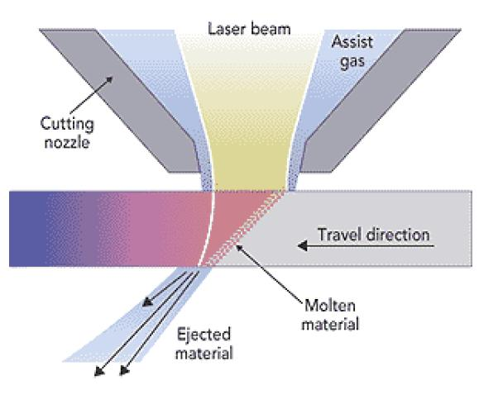

Figure 13.2Gas-assisted Laser Cutting

**2) LBM Cutting (Figure 13.2)**

-LBM Cutting = (Laser beam) + high velocity gas to melt, vaporize and oxidize (air, argon (used to prevent oxidation), oxygen (highest cutting speeds))

- Cutting of stainless steel is very wide.

-Holes with diameter larger than 10 mm or holes that are not round are produced by CNC contour cutting.

-Trepanning can be used to produce holes with diameter range 0.5 - 10 mm. L/D = 20/1 (Figure 13.3).

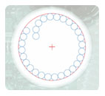 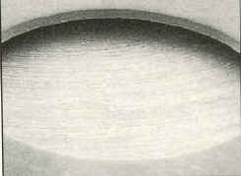 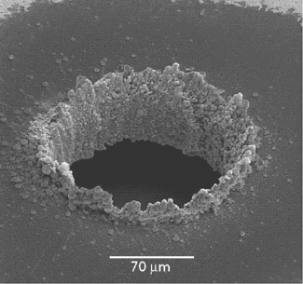

Laser trepanning Hole trepanning Micro hole trepanning

Figure 13.3 Laser trepanning

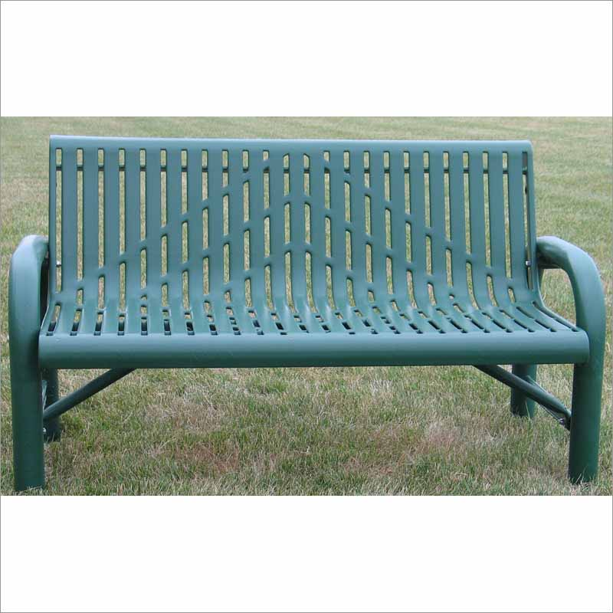 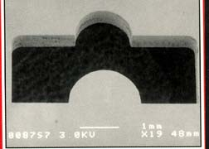 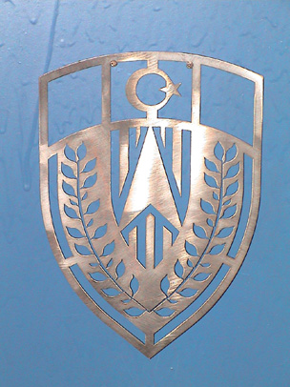

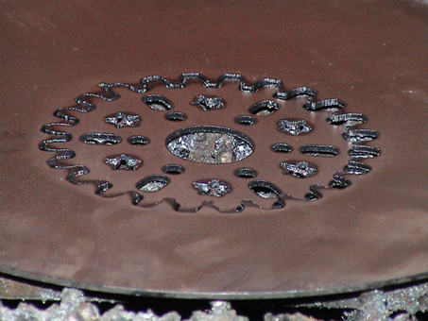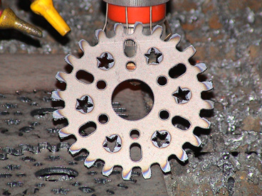

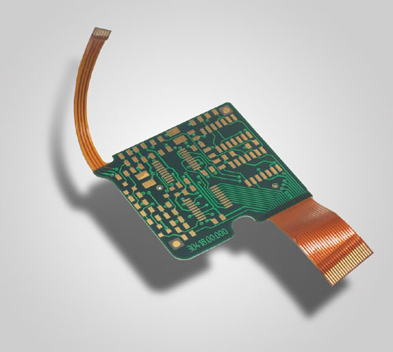 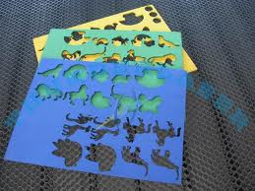

Figure 13.4 LBM Cut Parts

[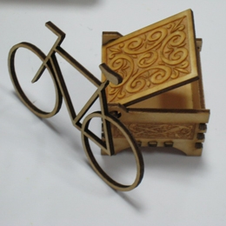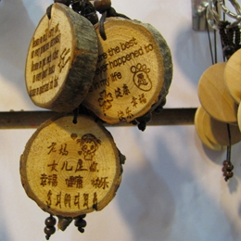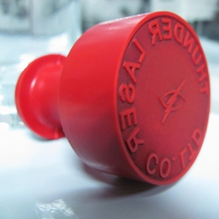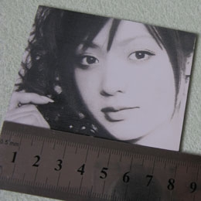](javascript:;)

Wood engraving Wood engraving Stamp engraving Photo engraving

[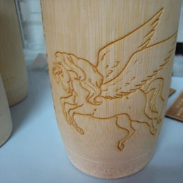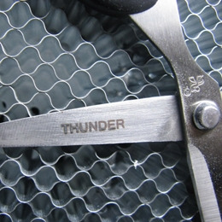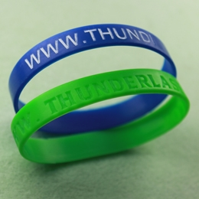](javascript:;)

Cylinder items Metal engraving Plastic engraving

Figure 13.5 Laser Engraving

**3) Laser Engraving (Figure 13.5):** Laser engraving (or laser marking) is the practice of using [lasers](http://en.wikipedia.org/wiki/Laser) to [engrave](http://en.wikipedia.org/wiki/Engraving) or mark an object. System is capable to engrave precisely on any metal and non-metal materials. YAG lasers (50-100W) and CO2 (80W/100W) are common. The engraving speed is 0-1000 mm/s. Worktables are electrical type with up and down movements.

**4) LBM Welding:** Used for spot and seam welding. Weld penetration is limited to a maximum of 2.5 mm.

**Advantages**

|  |  |
| --- | --- |
|  | -No contact between workpiece and cutting tool |
|  | -Non-metallic materials can be machined (refractors, composites) |
|  | -Very thin layer of heat affected region |
|  | -Machining can be controlled by simply changing the direction of mirrors or lenses |
|  | -Very small diameters can be cut |
|  | -No harmful radiation |
|  | -Less skill of operators |
|  | -Easily adaptable for control systems |
|  | -Sharp corners can be cut by small spot of laser |
|  | -Laser head need not to be close proximity of workpiece (advantages for difficult accessibility cases). |
|  | -Can operate in any transparent environment like air, inert gas, liquids (some), KCl, germanium, diamond, glass, Zn Se, Cd Te. |

**Limitations**

|  |  |
| --- | --- |
|  |  is low (high energy cost) |
|  | -High initial cost (18.000 - 100.000 $) |
|  | -Needs cooling of laser material |
|  | -Depth of cut is limited |
|  | -Laser beam reflects (some metals are difficult to cut, like Al (difficult), Cu) |
|  | -Hole walls are irregular and tapered |
|  | -Difficult to control hole diameter tolerance (at most ± 5% of hole diameter) |
|  | -Not applicable for blind machining |
|  | -Recast layer and heat affected zone |

|  |  |
| --- | --- |
| Video. Contour cutting    Video. Pipe cutting      Video. Stainless steel cutting (0.8mm)    Video-High speed drilling (225holes/min) | Video. Thick steel cutting (20 mm thick)    Video. Drilling - Cutting (2mm thick)    Video. Steel sheet cutting (0.8 mm thick) |